**MODULE: 1**

* **What is software? What is software engineering?**
* the software is a computer program that provides a set of instructions to execute a user commands and tell the computer what to do.
* This software program is designed to run a computer application program and hardware.
* It is type of software application that help in the automation of the task based on the user input.
* **Explain types of software**

1. System Software
2. Application Software
3. Driver software
4. Middleware
5. Programming Software

1. System Software: it is software to manage computer hardware behavior to provide basic functionalities to users. ex. windows os, android
2. Application software: Application software is a computer program that performs a specific function, be it educational, personal or business.
3. Driver software: also known as a device driver. Device driver control the device and enabling them to perform their specific tasks that software is often consider type of system software.
4. Middleware: the term middleware describes software that mediates between application remote work request from an application in a computer that has one kind of OS. For example, middleware enables Microsoft windows to talk to word.
5. Programming software: Programming software is a program or set of programs which helps the software develops by giving them creating, debugging and maintaining other programs an applications.

* **What is SDLC? Explain each phase of SDLC**
* SDLC is a structure that imposed the software product that defined the process for planning analysis designing implementation testing and maintenance.

**SDLC = SOFTWARE DEVELOPMENT LIFE CYCLE**

1. Requirement
2. Analysis
3. Designing
4. Implementation
5. Testing
6. Maintenance

1.Requirement collection- process of identifying your project requirement from start to end. Requirements gathering is the process of understanding what you are trying to build and why you are building it.

2.Analysis – System analysis is there very important throughout any software development process as plays as it plays a significant determining factor in the success of any software project in terms of usefulness and delivery within established constraints and based on how well it performed.

3. Designing- It design lay out of page or application. Software design is a mechanism to transform user requirements into some suitable form which helps the programmer in software coding and implementation.

4. Implementation- Translating the detailed requirements and design into system components.

5.Testing- is where the development team tests the software for error and deficiencies. The testing process should ensure each unit of the software works well.

6.Maintenance – if tester finding a debug from implementation they return to the developer and then he resolving debug and implement code and then again send to the tester approve then it was given to user or customer.

* **What is DFD? Create a DFD diagram on Flipkart**
* DFD stand of “data flow diagram”.
* Through which we can represent the flow of data graphically on an information system.
* By using DFD we can easily understand the overall functionally of the system because the diagram represents the incoming data flow outgoing data flow and stores data in a graphical.
* It describes how data is processed in a system in terms of input and output

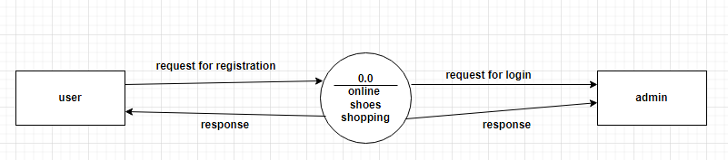  
 0 level DFD

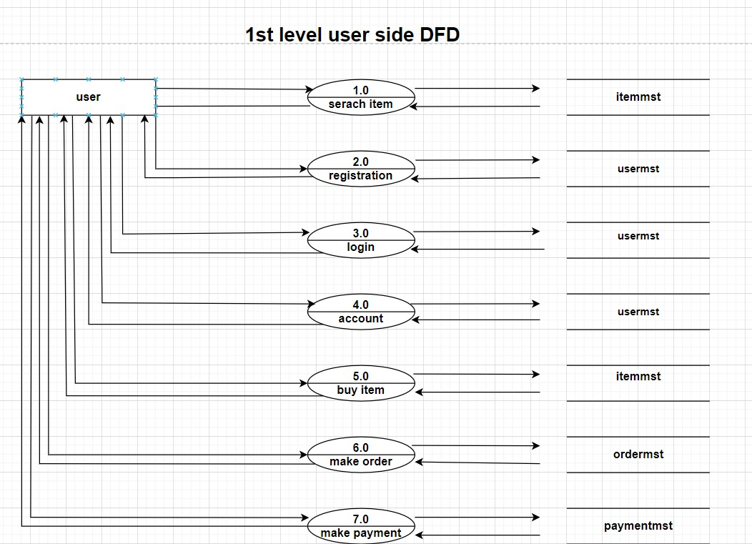

**What is flow chart? Create a flowchart to make addition of two numbers**

* A flow chart is a picture of the separate steps of a process in sequential order. It is a generic tool that can be adapted for a wide variety of purpose and can be used to describe and various process, such as manufacturing process an administrative or service process, or a project plan.

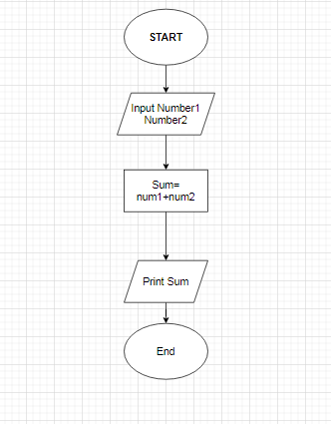

Flow chart of addition of two numbers

* **What is use case diagram? Create a use-case on bill payment.**
* A Use case is a written of how user will perform tasks on your website.it outlines, from a user’s point of view, a system’s behavior as it responds to a request. Each use case is represented as a sequence of simple steps beginning with a user’s goal and ending when that goal is fulfilled.

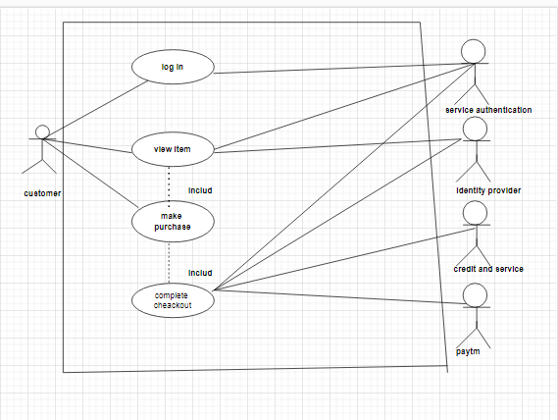

**ONLINE SHOPPING SYSTEM**